*Use the information in Chapter 11 (p.206-210) as well as the TED Talk by Bonnie Bassler:* [*How Bacteria “Talk”*](https://www.ted.com/talks/bonnie_bassler_on_how_bacteria_communicate?language=en#t-1067196) *and Bozeman’s* [*Evolutionary significance of Cell Communication*](http://www.bozemanscience.com/036-evolutinary-significance-of-cell-communication) *to complete this reading guide.*

**Concept 11.1: External Signals are converted to responses within the cell**

Briefly explain how bacteria use quorum sensing to communicate with one another.

Discuss how *Saccharomyces cerevisiae* cells use chemical signaling for mating. Draw a diagram to support your explanation.

Complete the following table summarizing the difference between the three major types of signaling.

|  |  |  |  |  |
| --- | --- | --- | --- | --- |
| Type of Signaling | | Diagram | Description | Example |
| Direct Contact | Cell junctions |  |  |  |
| Cell-cell recognition |  |  |  |
| Local Signaling | Paracrine signaling |  |  |  |
| Synaptic signaling |  |  |  |
| Long-distance | Endocrine signaling |  |  |  |

Use Figure 11.6 (p.209) to label the following diagram, then summarize each of the three stages of cell signaling below.

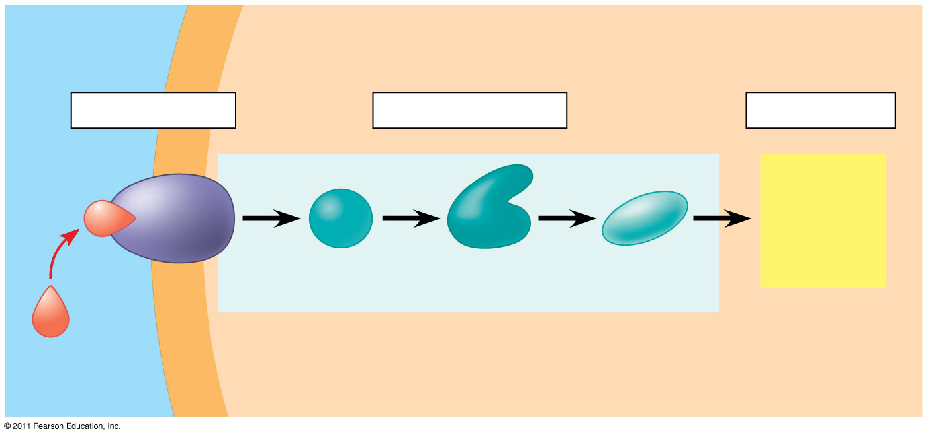

1. Reception
2. Transduction
3. Response